Jal Rekha

Low Level Design (LLD) Document

Material Testing Module
30-JAN-2026



Madhya Pradesh State Electronics Development Cooperation State IT Centre, 47-A, Arera Hills, Bhopal
https://mpsedc.mp.gov.in/

Project: Jal Rekha Water Management System
Module: Material Testing
Organization: Madhya Pradesh Jal Nigam Department
Developed By: MPSeDC
Document Type: Low Level Design (LLD)
Compliance: CMMI DEV Level-5
Version: 1.0

Date: January 2026

Table of Contents
- Introduction
1.1 Purpose
1.2 Scope
1.3 Definitions and Abbreviations
1.4 Reference Documents
- System Architecture Overview
2.1 High-Level Architecture Diagram
2.2 Technology Stack
- RFI Tracking Workflow (Detailed Process Flow)
3.1 As-Is vs To-Be Process
3.2 RFI Lifecycle State Diagram
- Component Design
4.1 User Interface Components
4.2 Business Logic Layer Components
4.3 Data Access Layer Components
- Data Design
5.1 Entity Relationship (ER) Diagram
5.2 Database Schema Definition
5.3 Data Validation Rules
- Sequence Diagrams (Core Workflows)
6.1 Contractor Initiates RFI
6.2 GM Assigns RFI to Field Engineer (FE)
6.3 FE Adds Comments and Submits
6.4 GM Accepts/Rejects RFI
- API Design
7.1 RESTful API Endpoints
7.2 Request/Response Payloads
- Security Design
8.1 Authentication and Authorization
8.2 Data Encryption
8.3 Audit Logging
- Error Handling & Logging
9.1 Exception Handling Strategy
9.2 Logging Framework
- Performance & Scalability
10.1 Caching Strategy
10.2 Database Indexing
10.3 Asynchronous Processing
- Metrics & KPIs for CMMI Compliance
11.1 Process Performance Objectives
11.2 Measurement Repository

- Introduction

1.1 Purpose
This document provides a detailed low-level design for the RFI (Request for Information) Anushravan Tracking sub-module within the Material Testing Module of the Jal Rekha system. Its purpose is to translate high-level requirements and the user manual specifications into a technical blueprint for developers and testers. This design facilitates a structured, auditable, and transparent communication channel between Contractors, General Managers (GMs), and Field Engineers (FEs) regarding queries on material testing.

1.2 Scope
This LLD covers the complete lifecycle of an RFI, starting from its initiation by a Contractor, through assignment and comment addition by a Field Engineer (FE), and concluding with its acceptance or rejection by the General Manager (GM). It includes user interface logic, backend services, database design, API contracts, and security considerations. It is scoped to the workflow: Contractor -> GM (Assign) -> FE (Comment) -> GM (Accept/Reject) .

1.3 Definitions and Abbreviations
Abbreviation | Full Form | Description
RFI | Request for Information | A formal query raised by a Contractor  regarding test specifications, results,  or procedures.
FE | Field Engineer | The role responsible for visiting the  site/source and providing clarifications.
GM | General Manager | The approving authority who manages  the workflow and makes final decisions.
TPIA | Third Party Inspection Agency | Agency responsible for testing,  can be a subject of an RFI.
FE | Front-End / UI Layer | The presentation layer of the  application.
BE | Back-End / Business Layer | The server-side logic and  processing layer.

1.4 Reference Documents
- Software Requirements Specification (SRS) for Material Testing Module v2.0
- User Manual: Material Testing Module v1.0 (Provided)
- Jal Rekha System Architecture Document v3.1

2. System Architecture Overview
The RFI Tracking module follows a modern, layered architecture to ensure separation of concerns, maintainability, and scalability.

2.1 High-Level Architecture Diagram

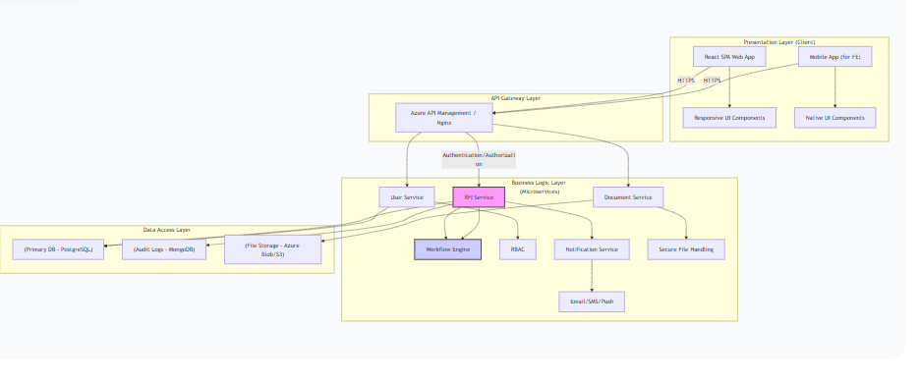

2.2 Technology Stack
- Frontend: React.js (Web), React Native (Mobile)
- Backend: Java (Spring Boot) / Python (Django/Flask)
- Database: PostgreSQL (Relational Data), MongoDB (Audit Logs)
- API: RESTful (JSON)
- Security: JWT (JSON Web Tokens), OAuth 2.0, HTTPS
- Infrastructure: Cloud (AWS/Azure/On-Premise), Docker, Kubernetes

3.RFI Tracking Workflow
3.1 Detailed Process Flow
- Initiation: The Contractor logs into the web portal, navigates to the relevant material test record, and raises an RFI by providing a subject and detailed description.
- Notification: The system notifies the concerned GM about the new RFI.
- Assignment: The GM reviews the RFI and assigns it to a specific Field Engineer (FE) via the web portal, optionally adding initial instructions.
- Field Investigation: The FE receives a notification (in-app/push) on their mobile app, reviews the RFI, and conducts the necessary field investigation.
- Comment Submission: The FE adds their findings, comments, and any supporting documents/photos (geotagged as per user manual) via the mobile app and submits the response.
- Review & Decision: The GM is notified of the FE's response. The GM reviews the comments and supporting evidence.
- Accept/Reject:
  - Accept: If the information is satisfactory, the GM accepts the RFI, effectively closing the loop.
  - Reject: If the information is insufficient, the GM rejects the RFI with remarks, re-assigning it back to the same or a different FE for further clarification.
3.2 RFI Lifecycle State Diagram

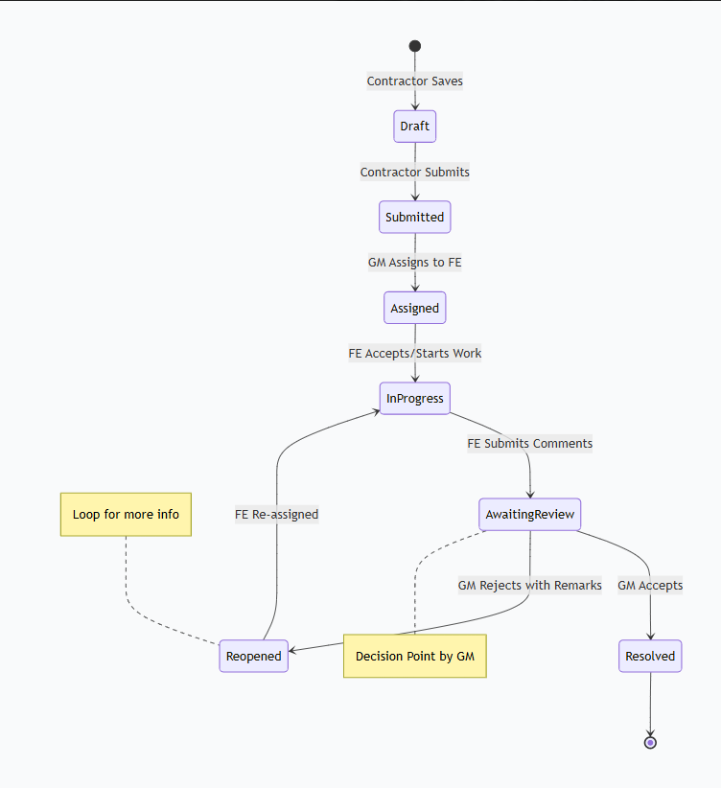

4. Component Design
4.1 User Interface Components
- RFI Creation Form (Contractor Web): Fields: Related Test ID, Subject, Description, Attachment Upload.
- RFI List View (GM Web/FE Mobile): Filterable list showing RFI #, Subject, Status, Priority, Created Date, Assigned To.
- RFI Details View (All Roles): Displays full RFI thread, including original query, GM instructions, FE comments, and decision history. Role-based actions (e.g., "Assign" button for GM, "Add Comment" for FE).
- Assignment Modal (GM Web): Dropdown to select a Field Engineer from a list, text area for instructions.

4.2 Business Logic Layer Components
- RFIOrchestrator: Manages the state transitions of an RFI. It validates if a state change is permissible based on the current state and user role.
- AssignmentManager: Handles the logic of assigning an RFI to an FE. It validates the FE's availability and assignment limits.
- NotificationManager: Triggers notifications (email, SMS, in-app) based on state changes (e.g., RFI_SUBMITTED, RFI_ASSIGNED, COMMENT_ADDED).
- DocumentValidator: Scans uploaded attachments for viruses, validates file types and sizes.

4.3 Data Access Layer Components
- RFIRepository: Interface for all CRUD (Create, Read, Update, Delete) operations on the rfi_master table.
- RfiCommentRepository: Interface for CRUD operations on the rfi_comments table.
- AuditLogRepository: Interface for writing immutable audit logs to the audit database.
5. Data Design
5.1 Entity Relationship (ER) Diagram

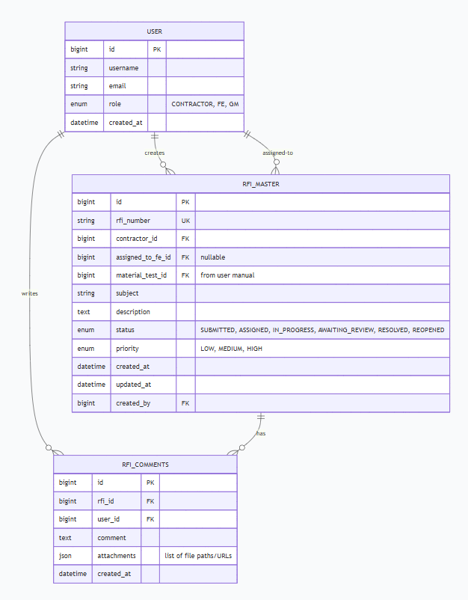

5.2 Database Schema Definition
- rfi_master: Central table for each RFI request. Stores all metadata, status, and ownership.
- rfi_comments: Stores the threaded conversation. Each entry is linked to an RFI and a user. Supports attachments.
- rfi_audit_log: (Not in ERD for brevity) Stores an immutable history. Fields: log_id, rfi_id, action (e.g., 'STATUS_CHANGE', 'ASSIGNMENT'), old_value, new_value, changed_by, changed_at.
5.3 Data Validation Rules
- RFI Creation: subject, description, material_test_id are mandatory.
- Assignment: assigned_to_fe_id must be a valid user with role 'FE'.
- Comments: comment text is mandatory. File attachments are optional but validated for type (pdf, jpg, png) and size (< 10MB).
- Accept/Reject: GM must provide a decision. If rejecting, a remark/comment is mandatory.
6. Sequence Diagrams
6.1 Contractor Initiates RFI
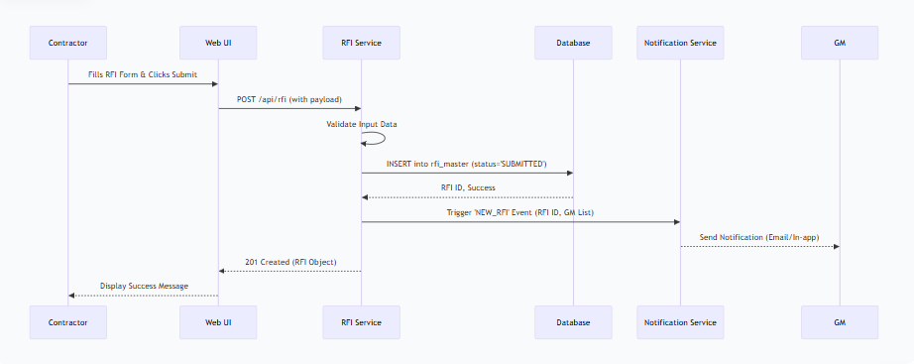
6.2 GM Assigns RFI to Field Engineer (FE)

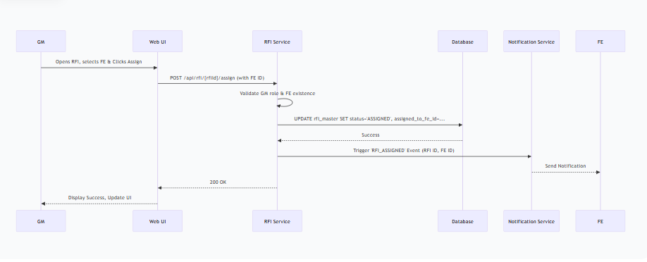

6.3 FE Adds Comments and Submits
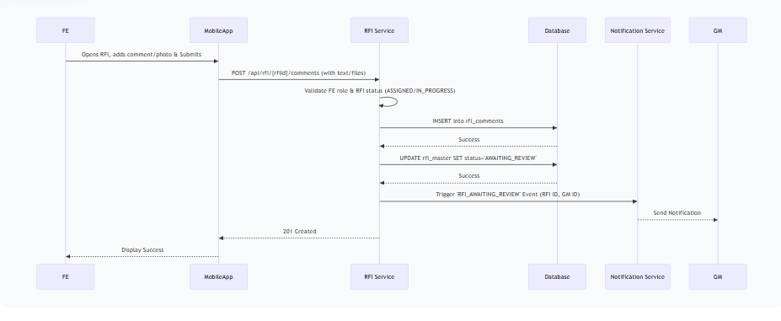

6.4 GM Accepts/Rejects RFI

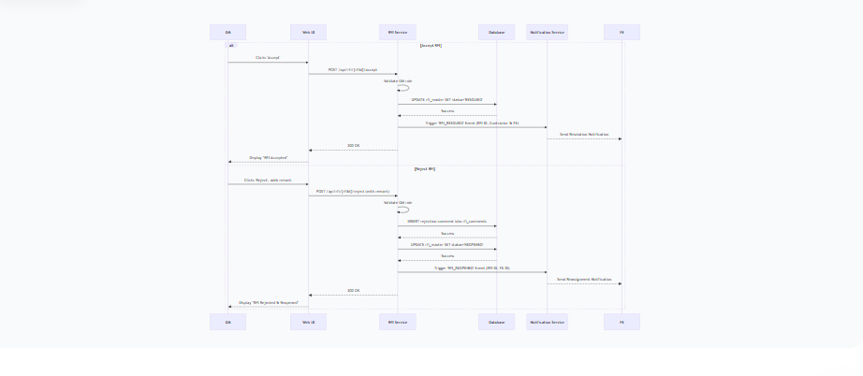

7. API Design
7.1 RESTful API Endpoints

Method | Endpoint | Description | Role
POST | /rfi | Create a new RFI. | Contractor
GET | /rfi | List RFIs (with filters: status, assignedTo, date). | Contractor, FE, GM
GET | /rfi/{rfiId} | Get details of a specific RFI. | Contractor, FE, GM
POST | /rfi/{rfiId}/assign | Assign RFI to an FE. | GM
POST | /rfi/{rfiId}/comments | Add a comment/attachment to an RFI. | FE, GM
POST | /rfi/{rfiId}/accept | Accept the RFI and resolve it. | GM
POST | /rfi/{rfiId}/reject | Reject the RFI, requiring more info. | GM

8. Security Design
8.1 Authentication and Authorization
- Authentication: JWT-based. Users log in with credentials, and the system returns a token containing user ID and roles.
- Authorization: Role-Based Access Control (RBAC). All API endpoints are secured with annotations/checks (e.g., @PreAuthorize("hasRole('GM')")). The backend validates that the user in the token has the necessary permissions for the action. Data-level security ensures a user can only access RFIs they are allowed to see (e.g., an FE sees only RFIs assigned to them).

8.2 Data Encryption
- In Transit: All communication between client and server is over HTTPS (TLS 1.3).
- At Rest: Sensitive data in the database is encrypted. Files uploaded (attachments) are encrypted in blob storage.

8.3 Audit Logging
Every state change, assignment, and critical view is logged immutably in the rfi_audit_log collection/table. This satisfies CMMI requirements for traceability.
- Logged Data: timestamp, user_id, user_role, action, rfi_id, ip_address, user_agent, details (JSON).

9. Error Handling & Logging
9.1 Exception Handling Strategy
A global exception handler (@ControllerAdvice in Spring Boot) will catch all exceptions and return standardized error responses.
json
{
"timestamp": "2023-10-27T12:00:00Z",
"status": 400,
"error": "Bad Request",
"message": "Validation failed for fields: [subject: must not be blank]",
"path": "/api/rfi"
}
9.2 Logging Framework
- Tool: SLF4J with Logback.
- Log Levels: ERROR for system failures, WARN for unexpected but handled issues, INFO for key business events (RFI created, assigned, etc.), DEBUG for development troubleshooting.
- Centralized Logging: All logs are shipped to a centralized system (e.g., ELK Stack - Elasticsearch, Logstash, Kibana) for monitoring and alerting.

10. Performance & Scalability
10.1 Caching Strategy
- Read-Heavy Data: Frequently accessed, static data like user details and RFI metadata for list views will be cached in Redis.
- Cache Eviction: Cache entries will be invalidated when an RFI is updated (status change, new comment).

10.2 Database Indexing
Indexes will be created on frequently queried columns in the rfi_master table to ensure fast search performance as the data grows.
- status
- assigned_to_fe_id
- contractor_id
- created_at
- Composite index on (status, assigned_to_fe_id)

10.3 Asynchronous Processing
Tasks that are not time-sensitive will be processed asynchronously to improve API response times.
- Notification sending: When an RFI is submitted, the API quickly returns success to the user, while a background job (e.g., using RabbitMQ/Kafka) handles sending emails/push notifications.
- Audit Logging: Writing to the audit log is also done asynchronously.

11. Metrics & KPIs for CMMI Compliance
To maintain CMMI DEV Level 5, we will quantitatively manage the process.
11.1 Process Performance Objectives
Metric | Description | Goal/Baseline | Collection Method
RFI Closure Time | Avg. time from "Submitted" to "Resolved". | < 48 Hours | From rfi_audit_log timestamps
FE Response Time | Avg. time from "Assigned" to "Comment Submitted". | < 24 Hours | From rfi_audit_log timestamps
GM Decision Time | Avg. time from "AwaitingReview" to "Resolved/Reopened". | < 12 Hours | From rfi_audit_log timestamps
RFI Rejection Rate | % of RFIs that are rejected by the GM. | < 15% | (Total Rejected / Total Resolved) * 100
System Availability | Uptime of the RFI service. | 99.9% | Infrastructure monitoring tools

11.2 Measurement Repository
All collected metrics will be stored in a centralized repository and visualized on a Process Performance Dashboard. This dashboard will be used in periodic project reviews to identify trends, predict potential delays, and drive process improvements, fulfilling the CMMI Level 5 requirement for "Quantitative Process Management" and "Causal Analysis and Resolution".

